TITLE:

New Generation Distributed Learning: Models of connecting students across distance and cultural boundaries

AUTHORS:

Dr Romana Martin
Faculty of Education, Queensland University of Technology
Romana.martin@qut.edu.au

Professor Tania Broadley
Faculty of Education, Queensland University of Technology
Adjunct, School of Education, Curtin University
Tania.broadley@qut.edu.au

KEYWORDS:

Distributed learning; new generation learning spaces; regional and remote education; teacher professional development.

POTENTIAL REVIEWERS:
Dr Susan Ledger
Dr Graeme Lock
Dr Sue Trinidad

ETHICS:

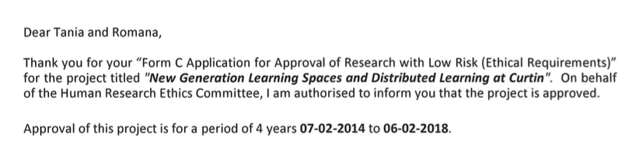

RESEARCH FINDINGS:
- This paper provides models of new generation distributed learning which have not previously been documented.
- Findings indicate that pedagogies and frequencies of learning are key to the successful student learning experience at all geographical locations.
- A framework for planning has been developed and disseminated.

